CAED Support Shop

**JOINTER**

**•Review dress code**

-Remind students that long hair must be tied back, loose clothing and/or jewelry must be removed

**•Why the Jointer?**

-Is there another tool that will do the same job SAFER? Example: Using the table saw to rip the rounded corners off a 2x4

-Discuss tool strengths

-Ability to make material straight and square

-Great for preparing edges to be JOINED or glued together

-Good for face jointing to remove warp such as cup, twist, bow, and crook

**•Describe How machine works**

-Describe the cutter head location and direction of rotation

-Describe the infeed and outfeed table, and how the infeed table is lower, as the workpiece is fed across the cutter it removes material and is supported by the outfeed table which is at the same level as the cutting arc (Material fed from right to left)

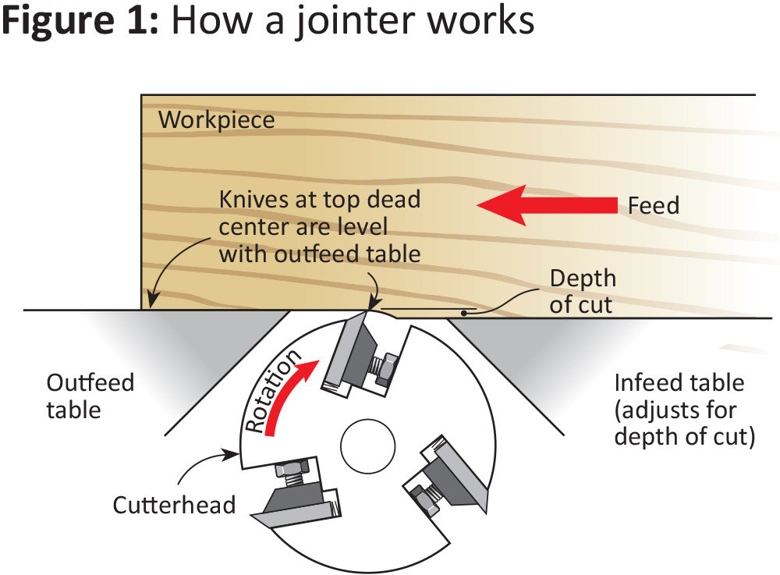

-Describe/show grain direction

-Emphasize by drawing on material

-Explain/Show how the grain establishes feed direction

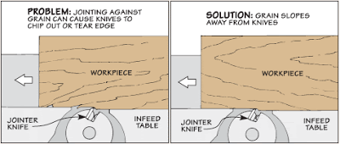

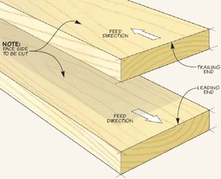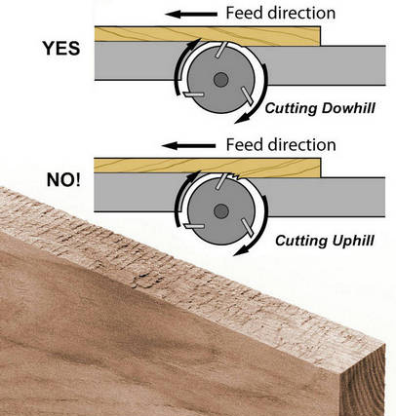

Bark Side down Grain Arrows Advance

Bark Side up Grain Arrows Retreat

-It’s like petting a dog, pet the fur in one direction and it will lie flat, pet the other direction it will raise the fur, always go with the grain

-Material is fed right to left.

-Show how flipping material end for end maintains correct feed/grain direction

**•Discuss and Demonstrate importance of:**

-Body Position, stand close to machine, don’t lean or over reach

-Smooth consistent motion, right to left, don’t force material through

-Hand Position, closed “fist and thumbs-up” hand position

-Use of push sticks and pads (Always required when face jointing and when running material less than the height of the fence)

**•Briefly Discuss Hazards** (No Horror Stories)

-User condition can be hazard ie; lack of sleep, in a hurry

-Over reaching/improper body position

-Hands coming into contact with cutter head

**•Discuss Material Requirements**

-“Clean” material only- No: paint, concrete, dirt, nails, staples, screws

-12” minimum length; 1/2” minimum thickness

-NEVER cut end grain or material shorter than 12”…EVER!!!

-Show students the **go/no go gauge** located between the two jointers, **if the wood fits, DO NOT use the jointer**

-Machine is designed for wood. Any other materials need to be cleared with shop staff

**Making Cuts**

**•Show/Demonstrate Controls**

-On/Off switch

-Infeed table height adjustment

-Fence angle adjustment and movement to adjust for board width

-Demonstrate how to check the fence/table alignment (angle) with a square

* **Edge Cuts (Each student makes 2 cuts)**

**1) Material taller than the fence (Push Blocks Not Required)**

-Emphasize closed “fist and thumbs-up” hand position

-Review body position and feed motion, right to left

-Keep material flat on table and against the fence, do not apply excess downward pressure, this will counteract the flattening/straitening process, as the material will spring back after pressure is released

-Test Material with go/no go gage

-Perform example cut

-Field questions then have students make cut

**2) Material Shorter than fence (Push Blocks Required)**

-Test Material with go/no go gage

-Demonstrate an edge cut utilizing push blocks

-Emphasize push blocks are required for material less than the height of the fence

-Field questions then have students make cut

* **Face Cuts**

-Material must be MINIMUM of ½” thick for face/flat cut

-Remind students they **MUST** use push blocks when making any flat cut

-Test Material with go/no go gage

-Demonstrate face cut

-Field questions then have students make cut

**•Remind students to clean-up after themselves after using a tool or area.**

-Show them where the brooms, vacuum, etc. are located and what our expectations for clean-up are.

-Remind them particle board, OSB, MDF, Melamine, and finished material goes in the **TRASH**.  Wood and Plywood can be recycled.

-Remind students they are responsible for emptying the chip bin

-Have the students clean up

  Ask students the following questions:

-When is it ok to cut end grain on the Jointer?

**NEVER**

-What is the MINIMUM length and thickness of material that may be run through the Jointer?

**12” long, 1/2" thick**

-The jointer is used to:

**Prepare the edge for joining to another piece and straighten/flatten a piece of wood, and should only be used on material that is at least 12” long**

-When running the wider/flat side of a piece of wood on the Jointer when should you use the push tools?

**ALWAYS**

-When facing the jointer, what direction is the material fed across the tool?

**Right to Left**

**Remind students:**

**NEVER use end grain on the jointer**

**NEVER use a piece of material less than 12” in length or ½” in thickness**

**ALWAYS use push blocks wile face jointing and when material height is less than the fence**

Closed “fist and thumbs-up”

**REMEMBER-We are here to help. If you have any questions, ask!**